# Kewaunee - Installation Document

Following steps needs to be followed while installing Kewaunee installer,

* Click Kewaunee 2016 installer.
* Once clicked , welcome page from the installer will get popped up.

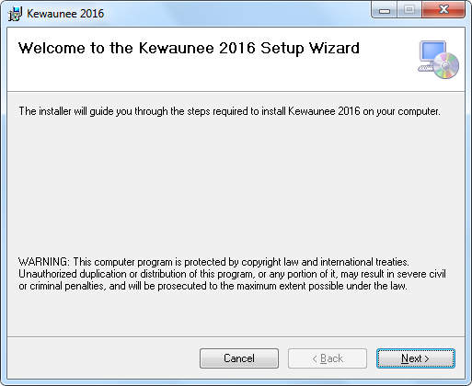

* Click Next button to proceed next.
* Once clicked, it will proceed to confirmation page.

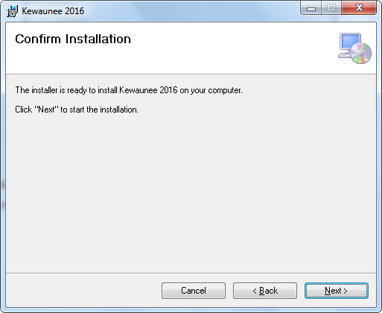

* In confirm installation page, click Next to proceed.
* By clicking cancel will interrupt the installation and Back will proceed back to welcome page.
* By clicking Next , will proceed to installation.

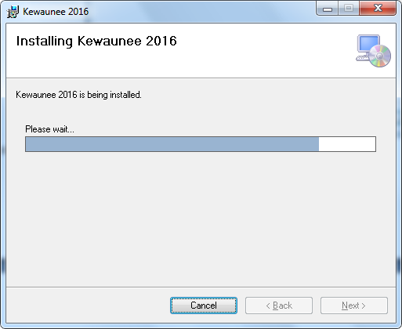

* Once progress finished , it will proceed back to completed page.
* That's the intimation of completion of installation.

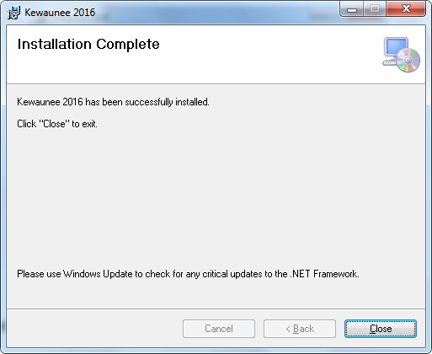

Once the installation is completed the executables will get placed in to following folder.

* "**C:\ProgramData\Autodesk\Revit\Addins\2016"**

In the following file, configure the connectionstring (database connectionstring) if needed.

**C:\ProgramData\Autodesk\Revit\Addins\2016\Kewaunee\Revit\Settings.txt**